Project Plan

California state university, long beach

Illuminati Deluxe

Zhipeng Mei, Patrapee Pongtana, Darrian Bezayiff

2017

**Table of Contents**

Overview …………………………………………………………………………………………………………2

Staff Organization…………………………………………………………………………………………….4

Risks Management…………………………………………………………………………………………..5

Project Estimate……………………………………………………………………………………………….7

Project Schedule………………………………………………………………………………………………9

**Overview**

**Project Scope**

Illuminati Deluxe is a graphical computer card game. This game plays in real time, and involve at least 3 (maximum 7) players online. This idea is to digitize the 1995 *Illuminati: The Game of Conspiracy* by Steven Jackson. It allows players from anywhere of the world to participate and become a ruling elite.

The game will consist of several inputs, graphically guiding users to navigate the game play interface including the following:

* Keyboard and mouse inputs
  + Card manipulation
  + Customize profile information
  + Communicate in Chat interface
* Network inputs
  + Backend retrieve data from database in real-time

Output includes:

* Data table would be stored in the real-time database
* Graphical feedback during game play

**Major Software Functions**

*User Authentication*

* This function is to verify and authenticate users. User must agree to the private policy and term of use agreement to use any service of Illuminati Deluxe. User will be able to sign in with a username and a desired password. Data would be sent to database for verification. If existing user is found then permission for sign in is allowed. Else, new user is required to sign up.

*Game Rule Enforcement*

* Rules are enforced. Players must follow the options given during each turn. Timer, graphical interface and hints will be provided to aid players during the game play.

**Management and Technical Constrains**

The deadline for this project is estimated to be May 10, 2017.

Illuminati Deluxe design and implement phase will be using Rapid Prototyping model.

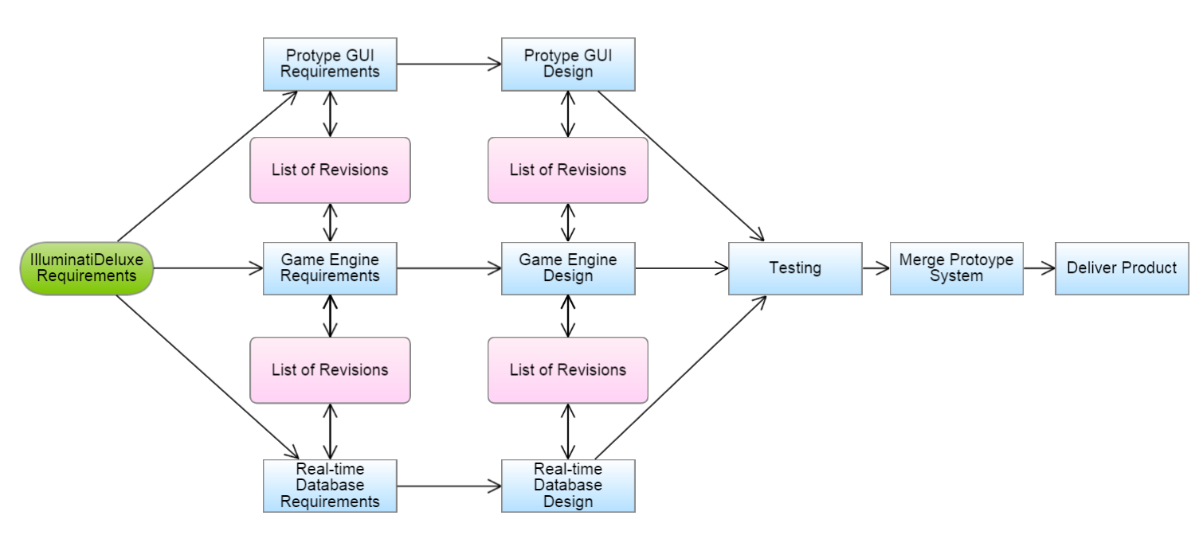

**Staff Organization**

**Role**

All team members are responsible to collaborate.

|  |  |
| --- | --- |
| Role | Database Designer |
| Member | ZHIPENG MEI |
| Description | This person is responsible for managing the project. As well as design the database. And anything to aid other team members. |

|  |  |
| --- | --- |
| Role | User Interface Designer |
| Member | PATRAPEE PONGTANA |
| Description | This person is responsible for developing UI. Collaborate closely with Game Engine designer to optimize the game play experience. |

|  |  |
| --- | --- |
| Role | Game Engine Designer |
| Member | DARRIAN BEZAYIFF |
| Description | This person keeps track of all documentations. As well as develop the game engine. Collaborate closely with database designer to store and retrieve data effectively. |

**Risk Management**

**Project risk**

Major risks we have determined for this software are as follows:

* Failed functioned game
* Server crash
* Late delivery
* Unsecured testing network
* Bluescreen of Death
* Collision codes in GitHub
* High reservation space for database
* Glitch graphics in GUI
* Poor comments in code
* Merging code within expected planned date
* Conflicted input of ideas
* Failed meeting on expected planned date

**Risk Table**

|  |  |  |  |
| --- | --- | --- | --- |
| Risk | Category | Probability | Impact |
| Failed functioned game | Progression | 70% | 1 |
| Server crash | Database | 50% | 1 |
| Late Delivery | Business | 40% | 1 |
| Unsecured testing network | Security | 20% | 1 |
| Bluescreen of Death | Kernel | 1% | 1 |
| Collision codes in GitHub | Cooperation | 40% | 2 |
| High reservation space for database | Database | 30% | 2 |
| Glitch graphics in GUI | GUI | 30% | 2 |
| Poor comments in code | Cooperation | 60% | 3 |
| Merging code within expected planned date | Cooperation | 40% | 3 |
| Conflicted input of ideas | Cooperation | 20% | 3 |
| Failed meeting on expected planned date | Cooperation | 50% | 4 |

Impact Values: 1 – Severe, 2 – Critical, 3 – Negligible, 4 – Extra Task / Non – important

**Overview of Risk Mitigation, Monitoring, and Management (RMMM)**

The most priority risk to be taken care of is the functional game that can be implemented early to test and fix the glitches and bugs in future cases. The application is using Firebase to host the server, thus, it is equally important risk to be taken care of. The risk will increase as the communication is getting worse, because each of the team members have different talent in each field, such as database, GUI, and coding logic. To determine certain problem, the probability must be considered every time the team members make a progression on the application

**Project Estimates**

Documentation: Estimated Date of Completion

1. Vision Document Feb. 20, 2017

*The document which outlines the purpose of this project and what is hoped*

*to be achieved.*

1. Project Plan Feb. 27, 2017

*The document which gives a concrete plan of completion for the project.*

1. Flowchart/UML Mar. 15, 2017

*A diagram that helps visualize the relationships between classes.*

1. Use Cases Apr. 5, 2017

*A list which explains actions between all actors and the system.*

1. Test Plan Apr. 19, 2017

*A plan which tests case-by-case whether or not all functions are working*

*properly.*

1. User Manual/UI Layout Apr. 26, 2017

*Instructions for how to play the game and pictures of the ideal gameplay.*

Construction:

1. Basic Playability with Demo May 10, 2017

*A prototype version of the game is complete in which a player can win*

*or lose.*

1. UI May 10, 2017

*The graphics of the game are complete which makes the game feel more*

*complete.*

1. Rule Enforcement May 10, 2017

*This game has all the minute details that are included in the physical*

*game.*

Extra Credit:

1. Database with Database Documentation May 10, 2017

*An entity which will allow online gameplay between multiple users along*

*with its documentation.*

1. Profiles May 10, 2017

*Information about each user that will work in tandem with the database.*

1. Online Matchmaking/Play May 10, 2017

*Able to have at least a two-way interaction between multiple users.*

1. Chat May 10, 2017

*Allows users to talk with each other in game.*

1. Multiple OS Compatibility May 15, 2017

*Allows those who don’t have Windows to still play the game with all of the*

*same features.*

Project Resources:

1. Required Staff

* Lead Java Programmer
* Graphics User Interface Programmer
* Database Programmer

1. Required Hardware

* 3 Development Systems
  + Laptops

1. Required Software

* Windows 10 Operating System (3 Licenses)
* Eclipse Java IDE (3 Licenses)
* Firebase Server Java Software Development Kit (1 License)
* Adobe Photoshop (1 License)

**Project Schedule**

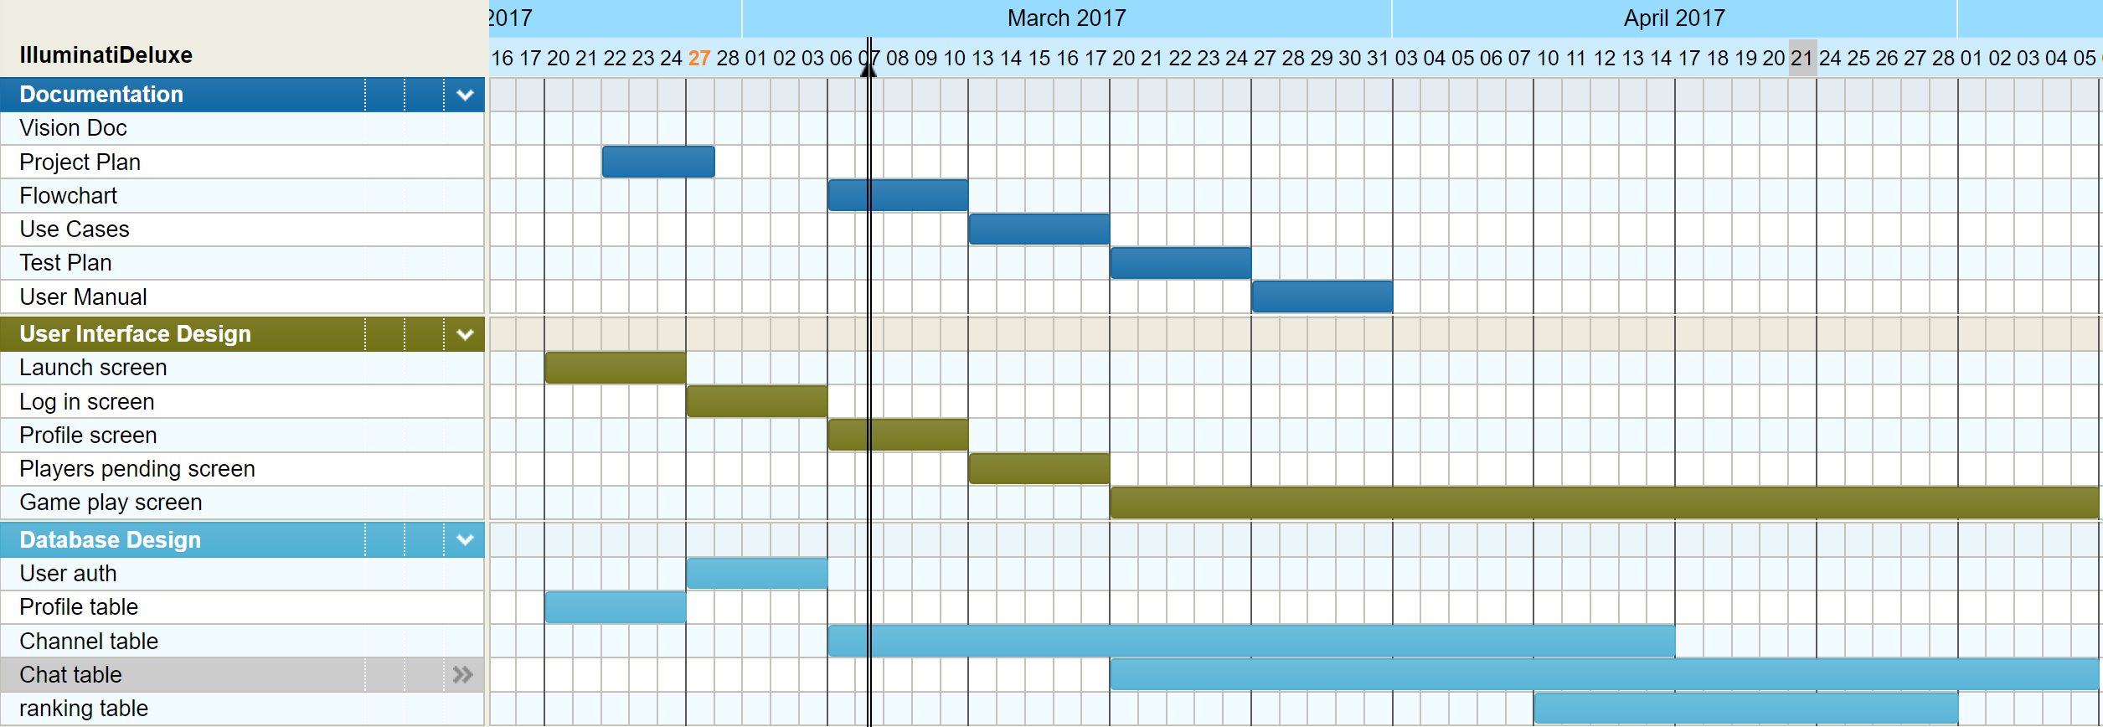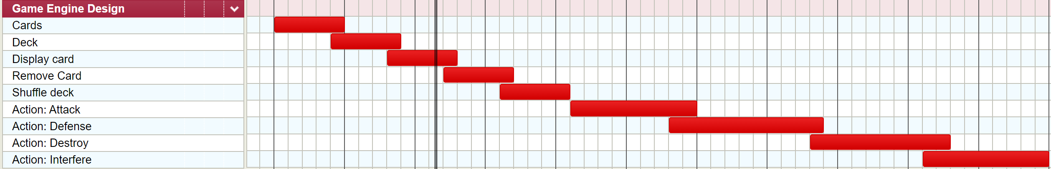

**List of deliverables**

|  |  |
| --- | --- |
| *Documentation:* | *Code:* |
| * Vision Doc * Project Plan * Flowchart * User Cases * Test Plan * User Manual | * Game Engine Prototype * Interface Mockup * Interface Database * Complete Game Engine * Complete Graphic User Interface * Functional Product |